Chatter Topics

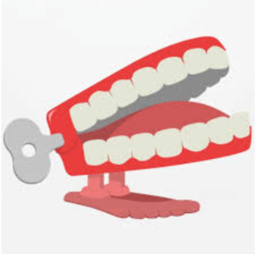
Question 1:
If someone in your family live during WW2
What do you know about their life during the war?
Question 2:
Does your family have any old photographs, letters, medals or keepsakes from the wartime period?
Question 3:
Did any of your relatives serve in the armed forces or help the war effort in another way?

