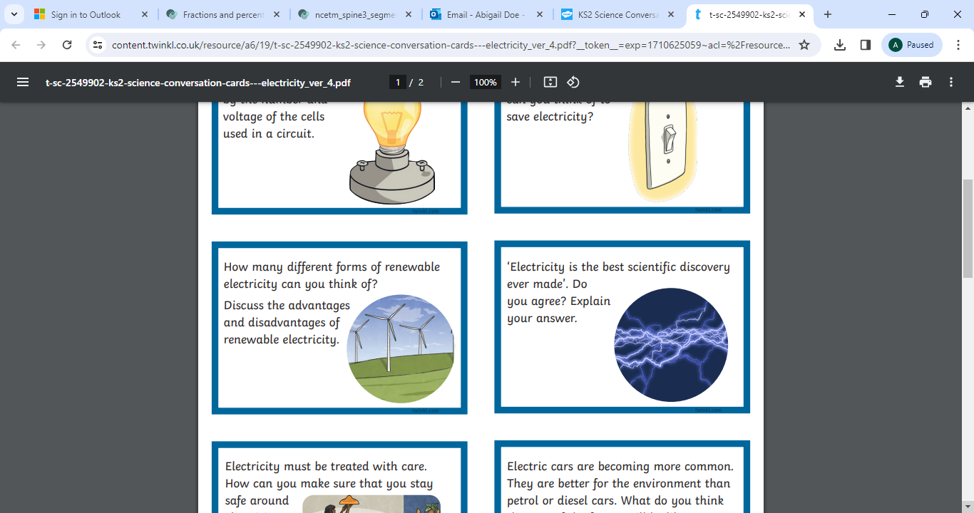 | 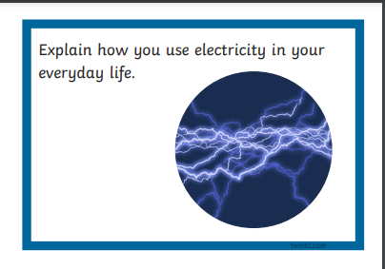
Electricity must be treated with care. How can you make sure that you stay safe around electricity?  Create a poster | Research a famous scientist who created an important electrical invention and present your findings.
Write about how different your life would be without electricity. What would you miss the most? | Electric cars are becoming more common. They are better for the environment than petrol or diesel cars.  What do you think the cars of the future will be like?  How do you think they will be powered?
https://www.switchedonkids.org.uk/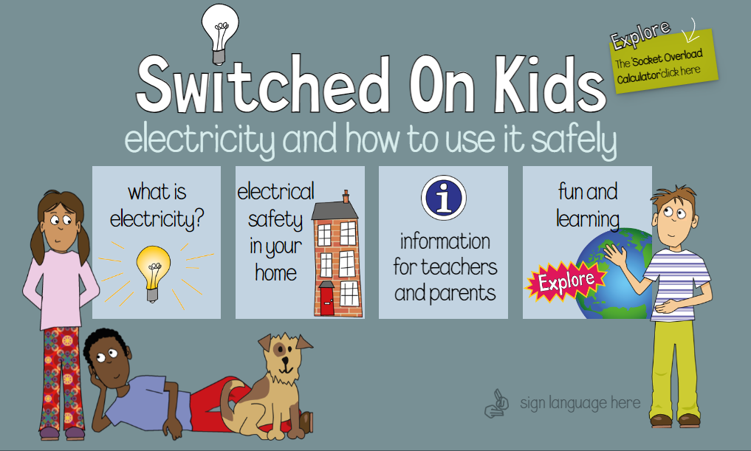 | Create a poster explaining the difference between a complete and incomplete circuit.

