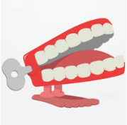

Summer 5
What are animals?
Chatter Topics for Dickens Class

Chatter topic 1: If You Could Be Any Animal, Which Would You Choose and Why?

Chatter topic 2: What animals make good pets, and why? What animals would not make good pets?
Chatter topic 3: Can you think of any animals that live in really cold or hot places? How are they suited to living in those places?

Chatter topic 4: How do different animals help our planet?

Chatter topic 5: What is your favourite animal and why?

