Skills and knowledge
 | Questions
1 | What significant changes have happened in Bath since 1066?
2 | What events, artefacts and historical figures from the time could you place on a timeline?
3 | What questions could you ask about the history and geography of Bath and what sources could you use?
4 | How can maps and fieldwork help me discover features of human and physical geography around Corsham and Bath?
5 | What do you like and dislike about Corsham and Bath and why?
Word | Definition
Spa | A spa is a location where mineral-rich spring water (and sometimes seawater) is used to give medicinal baths.
Primary source | A primary source is a work that gives original information. It is something that comes from a time being studied or from a person who was involved in the events being studied. Some primary sources supply factual information about a subject. Other primary sources express the views of people who experienced events.
Secondary source | A secondary source does not give original information. It interprets or summarizes information from primary sources. Textbooks, biographies, encyclopaedias, and dictionaries are normally secondary sources.
Human Geography | Human geography relates to human activity or something that is humanly-constructed.
Physical Geography | Physical geography relates to geography that is naturally occurring.
Field work | Fieldwork allows us to analyse our surroundings in real detail by measuring, collecting information, talking to people and using maps and equipment.
Grid reference | A grid reference tells you where something is on a map.
Era | A period of time in history
Interesting facts
The city of Bath gets its name from the Roman baths that were built there almost 2,000 years ago. The original name of the city was "Aquae Sulis," which means "the waters of Sulis" in Latin.
The River Avon is the 19th longest river in the United Kingdom, at 83 miles (134km).
It flows through the towns and cities of Chippenham, Melksham, Bradford on Avon, Bath and Bristol.

Rose

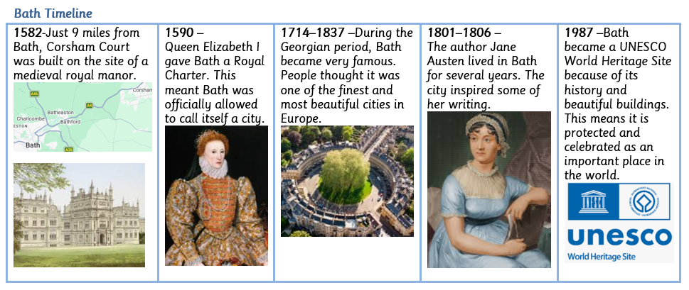

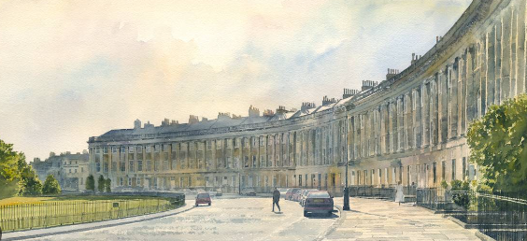
The Royal Crescent

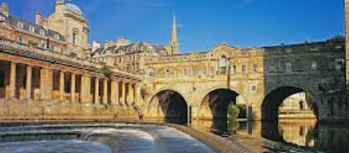
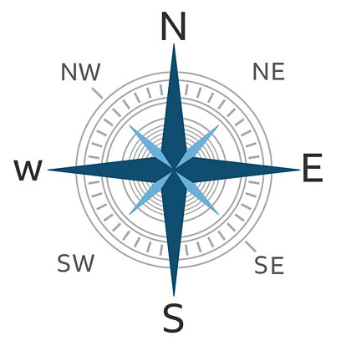
Compass Rose

Pulteney Bridge and shop backs

