

Where do I live?

 | Homework Options
Task 1 | Can you draw a map of your bedroom - pretend that you are looking down on it from above like this example.  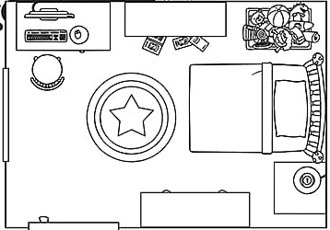
Task 2 | Can you draw or paint a picture of one of the historic buildings in Corsham? Here is one of Corsham Court for you to use if you wish.  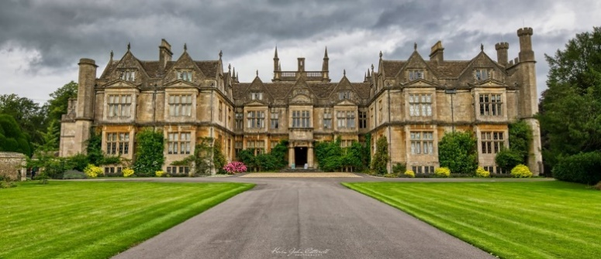
Task 3 | Can you write a story set in Corsham?
Task 4 | Can you write a list of human features in Corsham (buildings and things built by man) and a list of physical features (things which are natural and not built by man)?
Task 5 | 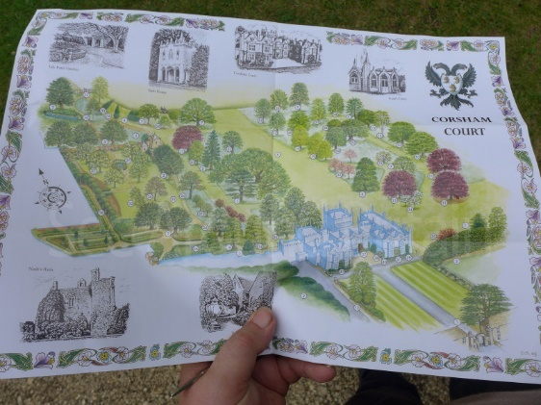  Create a poster or fact file all about Corsham – maybe you can use the internet to research information about the town. You could include information on how many people live here, the shops and other buildings that are in Corsham.

