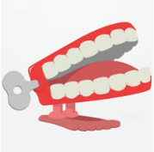

Spring 4
Where do I live?
Chatter Topics for Dickens Class

Chatter topic 1: If you could live anywhere in the United Kingdom, where would it be and why? Would it be in a town, village or city?
Chatter topic 2: If you could design and build something in Corsham what would it be? A new playground? An ice rink? An outdoor pool? A cinema? Something else?
Chatter topic 3: Look at this photo of Corsham Court taken over 100 years ago? What is different from houses you see in Corsham today?
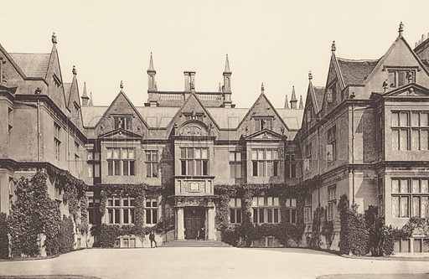

Chatter topic 4: What is your favourite place in Corsham and why?

