

The Arts in the 1940s

 | Homework Options
Task 1 | 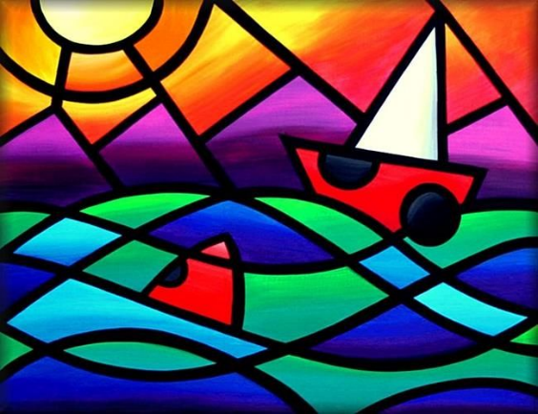  Cubism art was popular in the 1940s – this is picture made up from different shapes. Here’s a good example. Can you create your own art using 2D shapes?
Task 2 | Listen to some music from the 1940s. Can you draw a picture to match the music – what does it make you think of in your mind’s eye when you listen to it. Here’s a link to some 1940s music -  1940s Music, 1940s Music Hits with 1940s Music Playlist of 1940s Music Oldies Videos (youtube.com)
Task 3 | 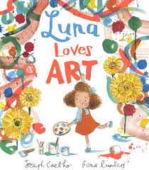  Luna Loves Art! Create three pieces of art that you would like to see in your own art gallery.
Task 4 | In the story, Luna learns about friendship. Draw a picture of you and a friend doing something fun together!
Task 5 | Based on Goodnight Moon.  “Imagine you are saying goodnight to your favourite things.  Write 3 sentences starting with ‘Goodnight…’.”

