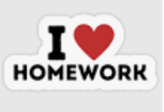

 | Homework Options
Task 1 | Go on a hunt around your home to find things made from wood, glass, plastic and metal. Draw a picture of them and label them.
Task 2 | Can you design a house for the future? What materials will the different parts be made from? Here’s some design ideas to get you started....  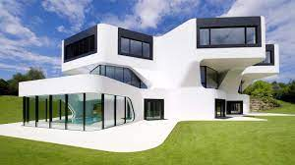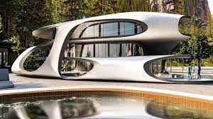
Task 3 | We need to recycle as many materials as possible. Can you design and draw a poster to encourage people to recycle? Remember to show what can be recycled. (You might have to do some research on the internet first to find out what can be recycled).
Task 4 | Build something using scrap materials that would be otherwise thrown away. (Remember to bring it in to show us).  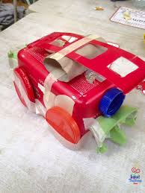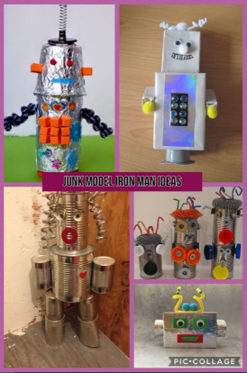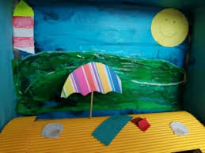
Task 5 | Record everything that you recycle for one week. Write it in a list and try to make sure that you recycle as many things as possible.
Task 6 | If something is transparent, it means that it is see through. If something is opaque, it means you cannot see through it at all. Can you create a table like the one below and make a list of at least 6 transparent things and 6 opaque things. We’ve added a couple of things to get you started.
  Transparent | Opaque
  Glasses | Book

