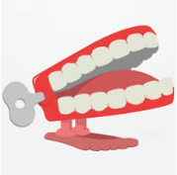
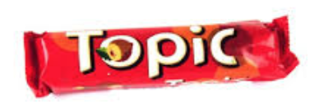
Autumn 2
What is it made from?
Chatter Topics for Dickens Class

Chatter topic 1: Glass has been used to create unusual things such as stairs and tables. What unusual thing would you design made out of glass?
Chatter topic 2: Which material do you think is the most important one used in our world today? Why do you think this?
Chatter topic 3: What was life like before plastic was invented? Which things that are made out of plastic would you miss most?

Chatter topic 4: What is your favourite toy made out of wood? Why do you like it and why is wood such a good material for it to be made from?

