Autumn 2
Chatter Topics for
Turner Class

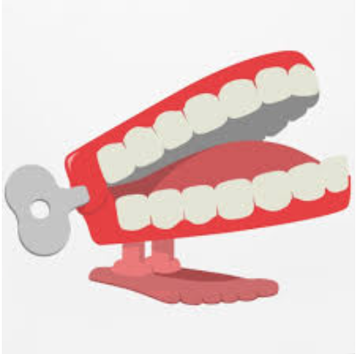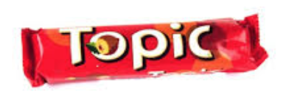

Chatter topic 1:

What are magnets used for?
Chatter topic 2:
If a ‘floating train’ was made using magnets, how would it work?
Chatter topic 3:

Could a magnet pull something through a table?

