**Autumn 1**

**Homework for Dickens**

**What were homes like in the past?**

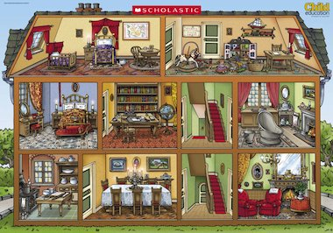

* **Make a model of your home or someone else’s. You could use cardboard boxes, lego, play bricks or something else.**
* **Research what homes people lived in during the Stone Age. Draw/write about what you have learnt.**
* **Draw a plan of your bedroom. Remember to include your bed and any furniture that you have in your room.**
* **Write a fact file about what you have learnt about homes in the Victorian era. You could write about how the kitchens, bathrooms and sitting rooms were different.**
* **Draw and label a picture of what you think homes will look like in the future in 100 years time.**