**Autumn 1**

**Chatter topics for Dickens**

**What were homes like in the past?**

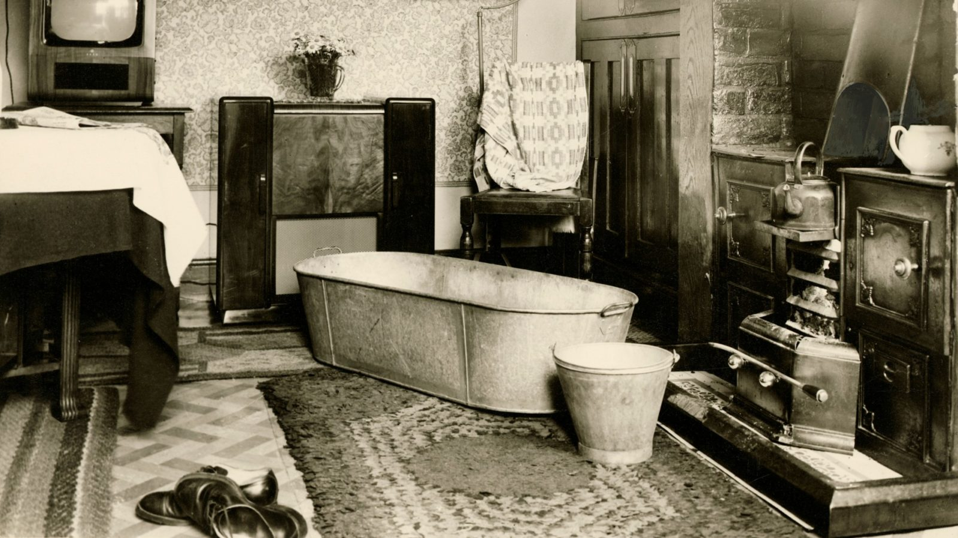

* Look at this picture taken of bath time in the Victorian era. How was it different to having a bath today?
* There was no electricity in the Victorian era. What things use electricity in your home and what made it much harder not to have electricity.
* What have you learnt about homes in the Victorian era? Is there anything you would like better and what would you least like about living in a home in this time?
* If you could design your dream home what would you have in it – you can dream big. So, you may want a swimming pool or a cinema room or a room for soft play. What would you have?