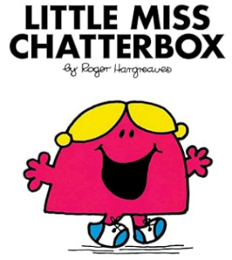**Millward Class**

**Chatter Topics**

**Autumn 1**

1. It’s a new school year, what are you most looking forward to and what do you hope to achieve?
2. We are doing a history topic this term. If you could choose any period in history to time travel to, which would it be? What would you most want to see?
3. Has anyone you know been to Scandinavia? What can they tell you? If not what part of Scandinavia would you like to visit, why?
4. We are learning a French story this term. Find out what languages your parents, grandparents, aunties and uncles learnt at school.
5. In PSHE, we will be thinking about Our Happy School. Find our from your family what they liked best about school.

