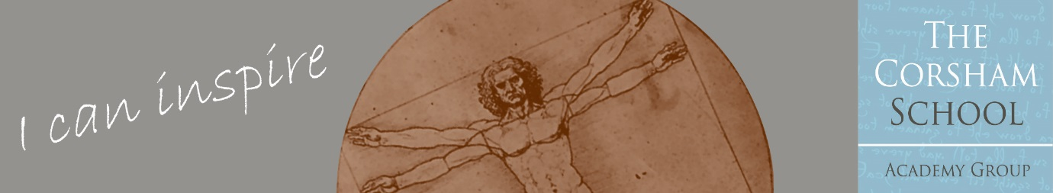**THE CORSHAM SCHOOL ACADEMY GROUP**

**A Multi Academy Trust**

Corsham Regis Primary Academy

JOB ADVERT

**SITE MANAGER & CLEANER**

|  |  |
| --- | --- |
| **SITE MANAGER** | |
| Dates: | Apply by 11am Friday 20th June 2025 |
| Start date: | 1st September 2025 preferred but can be negotiated with the successful candidate |
| Salary: | Grade F Point 8 £12,702 per annum (£13.47 per hour)  (Full Time Equivalent Salary £25,992) |
| Working: | 20 hours per week, 4 hours per day, split shift: 6.00am – 8.00am and 3.30pm – 5.30pm  Term Time Only + TD Days + 2 weeks |
| Contract Type: | Part Time, Permanent |

|  |  |
| --- | --- |
| **CLEANER** | |
| Dates: | Apply by 11am Friday 20th June 2025 |
| Start date: | 1st September 2025 preferred but can be negotiated with the successful candidate |
| Salary: | Grade B Point 2 £8,670 per annum (£12.26 per hour)  (Full Time Equivalent Salary £23,657) |
| Working: | 15 hours per week, 3 hours per day, split shift: 8.00am – 9.30am and 2.00pm – 3.30pm  Term Time Only + TD Days + 2 weeks |
| Contract Type: | Part Time, Permanent |

**The Role**

An exciting opportunity has arisen to join our friendly and committed team. In this role you will support the Headteacher and Administration & Resources Manager by taking a leading role in the **management** of the school site including the building maintenance, cleanliness, security and maintenance of furnishings, fixtures plant and heavy equipment to maintain a healthy and safe environment for students, staff and other users of the **school**’s premises.

This is a dual role where, ideally, one candidate will take on both roles in one recruitment process. However, we are open to receiving applications from candidates who are only interested in one role; working times may be adjusted in this instance.

Potential candidates for this role are warmly invited to visit the school, please contact [admin@corshamregis.wilts.sch.uk](mailto:admin@corshamregis.wilts.sch.uk)

**The School**

Corsham Regis Primary Academy is part of a small Multi Academy Trust serving the market town of Corsham. It is situated in North Wiltshire, on the outskirts of the Cotswolds, 8 miles from Bath and within easy reach of the M4.

Corsham Regis is a warm and friendly school where children are at the heart of the decisions we make.

Corsham Regis Primary Academy offers: -

* Commitment to your professional development
* A friendly, hardworking and supportive community
* Children who have positive attitudes to learning and eager to achieve
* A modern, well-resourced school
* A supportive governing body

As part of the remuneration package The Corsham School Academy Group offers excellent Employee Benefits, including a Contributory Pension Scheme, Employee Assistance Programme, Cycle to Work Scheme, together with discounts on High Street shopping, Cinema Tickets and Holidays.

If you wish to apply for this position, please apply via the application form. A separate letter (no more than 2 sides A4) addressed to the Headteacher should indicate how your qualifications and experience make you a suitable candidate for this post.

Please download and complete the Application Form, and return to the school via email to: [admin@corshamregis.wilts.sch.uk](mailto:admin@corshamregis.wilts.sch.uk)

Alternatively, a paper copy can be completed and returned to the school office.

Corsham Regis Primary Academy, as part of The Corsham School Academy Group, is an equal opportunities employer and is committed to safeguarding children and young people.  All appointments are subject to the school receiving two satisfactory references, one of which will include the current/last employer. This appointment is also subject to the provision of relevant documents to the school proving a legal right to work in the UK, clearance from the Disclosure and Barring Service of an enhanced check for regulated activity, and confirmation of professional qualifications.  On acceptance of a job offer, a pre-employment health check will be completed. The appointment is conditional on all the above checks being satisfactory.

In line with KCSIE 2024 and safer recruitment practices, the school will conduct an online search for all shortlisted candidates. The online search is part of our safeguarding checks and will seek publicly available information on candidates’ suitability to work with children. Shortlisted candidates will be provided with further guidance and will be asked to clarify their online presence.

It is an offence to apply for a role within regulated activity if the applicant is barred from engaging in regulated activity with children.