Home learning in Fox

In order to help your child learn, we encourage you to read with your child daily. This is to practise reading skills, comprehension and reading for pleasure. We would like you to spend time supporting your child to learn to read and spell some common exception words. You could concentrate on 5 of these at a time. These are available on our website. Counting up to 20 and beyond and back to zero help children understand the number line and practical adding and taking away of objects is also a great maths activity.

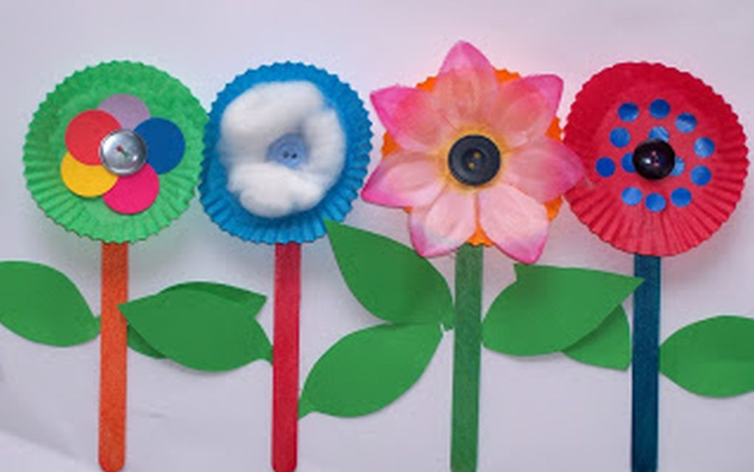

In addition to this we have some optional home learning linked to our topic this term, which is ‘How does your garden grow?’ If you would like to help your child with our topic this term below are some ideas:

* Go for a walk and try and identify some common plants and flowers you may find in your garden or local area
* Press some flowers in the pages of a book and then use them to create a picture.
* Draw, paint or use collage to create a picture of flowers or a garden.
* Try printing with flowers and leaves – dipping them in paint.
* Research why flowers need bees to pollinate them.
* Draw a picture of a plant and label it.