
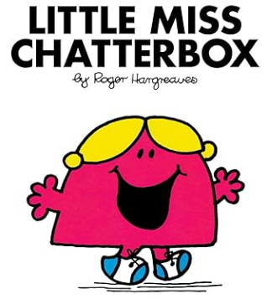
Millward Class
Chatter Topics
Summer 6
- Explain to someone at home what the features of biography writing are.
- Find out what animal your family members would be and why? What about you?
- Share with your family what you are looking forward to when you move up to your new school year.
- Ask everyone at home what their favourite plant, flower or tree is.
- How many different tree species can you and your family think of?


