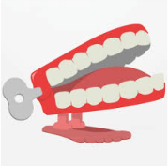**Dickens Class Chatter Topics**

**Summer 6**

**Chatter topic 1:** What is your favourite flower/tree? Why?

**Chatter topic 2:** What do you think plants need in order to grow?

**Chatter topic 3:** What happens to some trees in the Autumn and Winter? Does this happen to all plants?

**Chatter topic 4:** Can you think of any plants that grow in other parts of the world, but not in this country? Why do you think this is?