**Summer 6 Chatter Topics for**

**Fox Class**

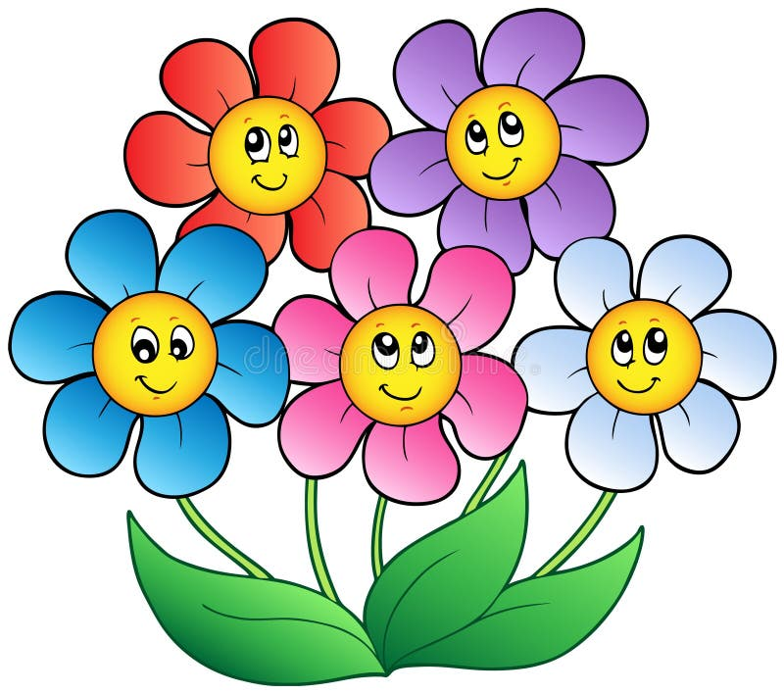

* What would the world be like without plants?
* What plants and flowers can you recognise and name?
* What animals need plants to survive?
* What do seeds need to grow?
* What do plants need to stay growing healthily?