Summer

Chatter Topics for

Turner Class

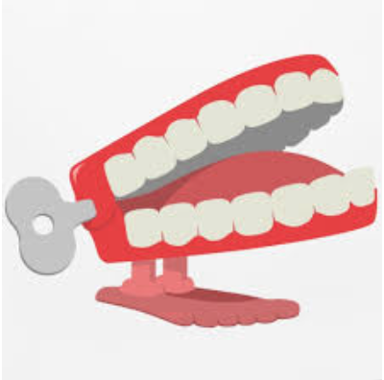

Chatter topic 1:

Can you think of examples of how animals or plants have changed over time?

Chatter topic 2:

Do you think evolution is a random process, or is there a purpose to it?

Chatter topic 3:

How do you think evolution might affect us in the future?