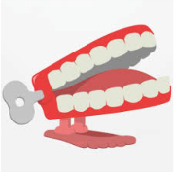**Dickens Class Chatter Topics**

**Summer 5**

**Chatter topic 1:** If you could be any animal, what would it be and why?

**Chatter topic 2:** If you were an animal, which habitat would you rather live in – desert, mountains or tropical rainforest? Why?

**Chatter topic 3:** Do you have any pets? Are they mammals, fish, birds, amphibians or reptiles? What do they eat?

**Chatter topic 4:** What are minibeasts? Can you think of any stories which have minibeasts in? (eg The Very Hungry Caterpillar)