**Summer 5 Chatter Topics for**

**Fox Class**

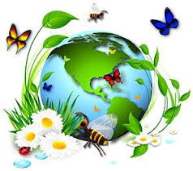

* What is an insect?
* What animals can you recognise and name?
* What creatures and wildlife might you find outside in Corsham?
* What do animals need to grow and survive?
* What is your favourite animal and why?