Human and Physical Geography | What do we know about our continent?
- Can you name and locate significant geographical features?
- How could you describe geographical similarities and differences in different regions?
- Can I name and locate countries in Europe?
- What are the names of the European capital cities?
- How does Human Geography change over time?
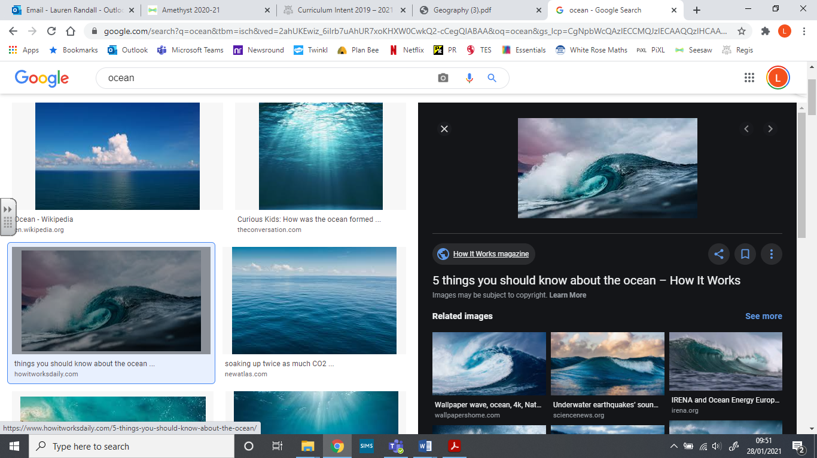

Related Milestones:
Geog M2:
• Describe geographical similarities and differences between countries. • Name and locate counties and cities of the United Kingdom, geographical regions and their identifying human and physical characteristics, including hills, mountains, cities, rivers, key topographical features and landuse patterns; and understand how some of these aspects have changed over time

