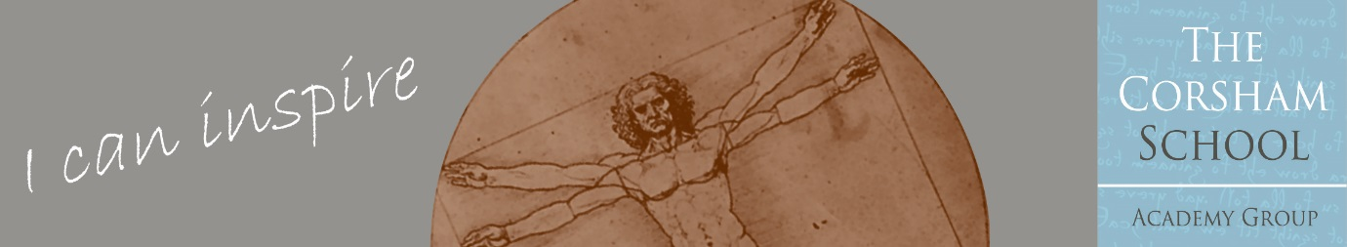**THE CORSHAM SCHOOL ACADEMY GROUP**

**A Multi Academy Trust**

Corsham Regis Primary Academy

JOB ADVERT

**Teaching Assistant**

|  |  |
| --- | --- |
| Closing Date: | Apply by midday on Monday 24th February |
| Start date: | Monday 10th March but can be negotiated with the successful candidate |
| Salary: | Grade B, £12.26 per hour  Full Time Equivalent Salary £23,657  Actual Salary £14,733 |
| Hours of Work: | Monday – Friday, 8.40am – 3.10pm with a 1-hour unpaid break  Term Time Only |
| Contract Type: | Permanent |

**The Role**

We are looking to appoint a flexible and enthusiastic Teaching Assistant to work with children of different ages and abilities. The successful applicant will be conscientious and possess the ability to communicate at all levels. Applicants will need to possess strong interpersonal skills and be able to demonstrate that they have excellent literacy and numeracy skills, as well as a calm, positive and encouraging personality. Relevant qualifications and experience would be an advantage but are not essential.

We want to hear from you if you have an interest in teaching or have had previous experience as a Teaching Assistant or volunteer with primary aged children. The successful applicant will be a dynamic and enthusiastic individual who is able to make the significant contribution required to secure the very best outcomes for all children at Corsham Regis Primary Academy. As part of our Induction Programme, full training will be given on our classroom procedures and protocols.

Potential candidates for this role are warmly invited to visit the school, please contact [admin@corshamregis.wilts.sch.uk](mailto:admin@corshamregis.wilts.sch.uk)

**The School**

Corsham Regis Primary Academy is part of a small Multi Academy Trust serving the market town of Corsham. It is situated in North Wiltshire, on the outskirts of the Cotswolds, 8 miles from Bath and within easy reach of the M4.

Corsham Regis is a warm and friendly school where children are at the heart of the decisions we make.

Corsham Regis Primary Academy offers: -

* A commitment to professional development and career progression opportunities
* A caring and supportive department, staff body and wider school community
* Children who have positive attitudes to learning and eager to achieve
* A modern, well-resourced school
* A supportive governing body

**Benefits**

As part of the remuneration package, Corsham Regis Primary Academy offers excellent Employee Benefits, including a Contributory Pension Scheme, Employee Assistance Programme, and Cycle to Work Scheme, together with discounts on High Street shopping, Cinema Tickets, and Holidays.

**Apply**

If you wish to apply for this position, please apply via the application form. Please also include a separate letter (no more than 2 sides A4) addressed to the Headteacher which should indicate how your qualifications and experience make you a suitable candidate for this post.

Please download and complete the Application Form, and return it to the school via email to: [admin@corshamregis.wilts.sch.uk](mailto:admin@corshamregis.wilts.sch.uk)

**We reserve the right to interview and appoint before the closing date, therefore early applications are encouraged.**

Corsham Regis Primary Academy, as part of the Corsham School Academy Group, is an equal opportunities employer and is committed to safeguarding children and young people.  All appointments are subject to the school receiving two satisfactory employer references, one of which will include the current/last employer. This appointment is also subject to the provision of relevant documents to the school proving a legal right to work in the UK, clearance from the Disclosure and Barring Service of an enhanced check for regulated activity, and confirmation of professional qualifications.  On acceptance of a job offer, a pre-employment health check will be completed. The appointment is conditional on all of the above checks being satisfactory.

In line with KCSIE 2024 and safer recruitment practices, the school will conduct an online search for all shortlisted candidates. The online search is part of our safeguarding checks and will seek publicly available information on candidates’ suitability to work with children. Shortlisted candidates will be provided with further guidance and will be asked to clarify their online presence.

It is an offence to apply for a role within regulated activity if the applicant is barred from engaging in regulated activity with children.