
Who is Yayoi Kusama?

 | Homework Options
Task 1 |   Draw a portrait or paint a picture of  Yayoi Kusama.
Task 2 | Look at Japan on a map. Which continent is it in?
Task 3 | Have a go at making your own vegetable-inspired artwork! Here are some examples by Yayoi Kusama…  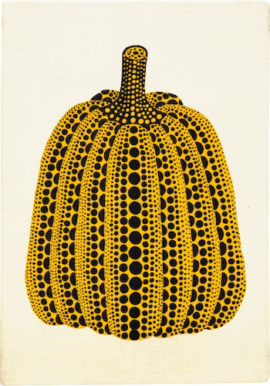  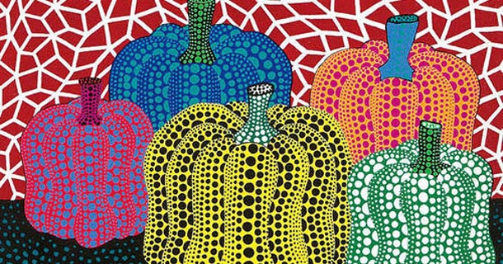    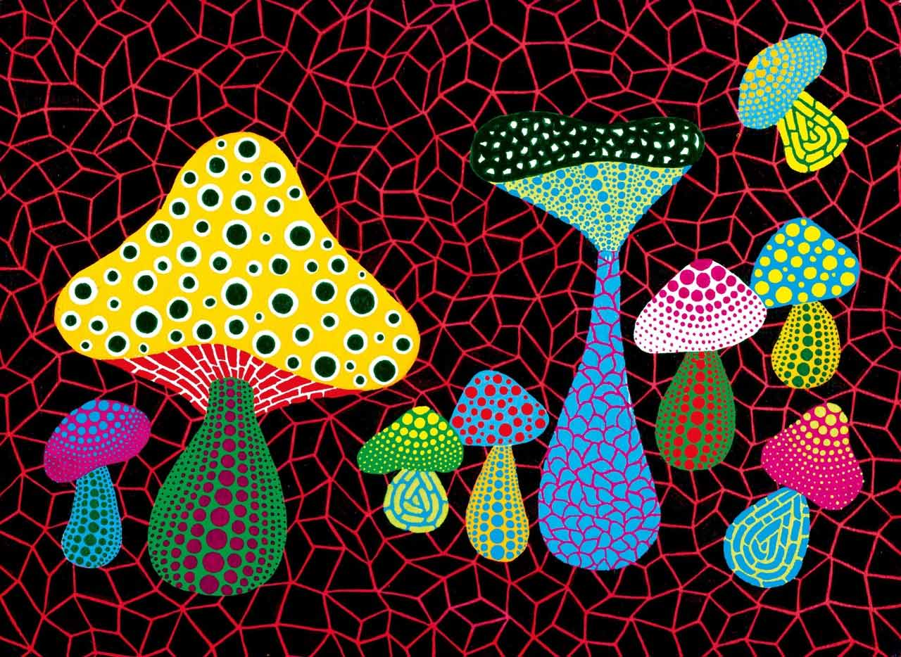
Task 4 | We are reading a Japanese story called ‘The Sound of Silence’. Write a list of all the sounds you can hear at home.
Task 5 | Can you design a kimono for a Japanese person? Here are some examples…  