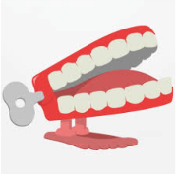**Dickens Class Chatter Topics**

**Spring 3**

**Who is Yayoi Kusama?**

**Chatter topic 1:** Do you like these art installations? Why/why not? How do you think Yayoi Kusama made them?

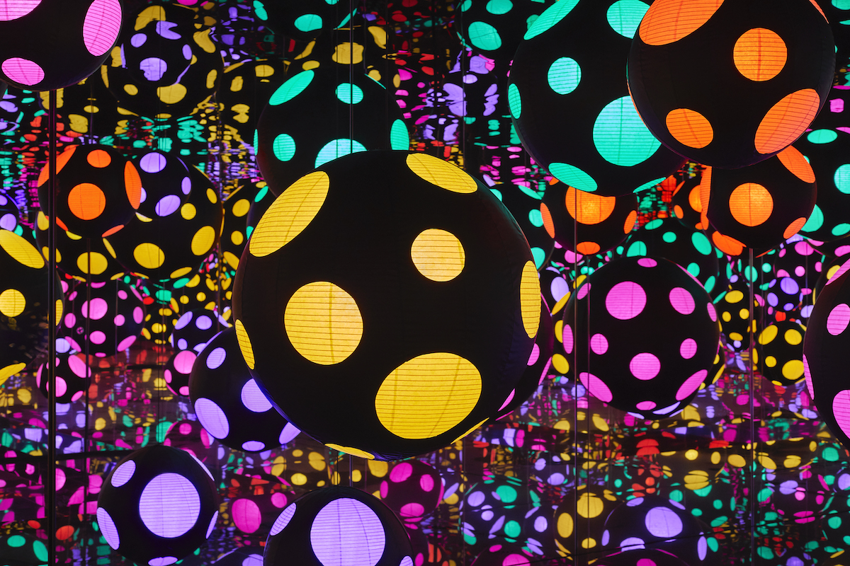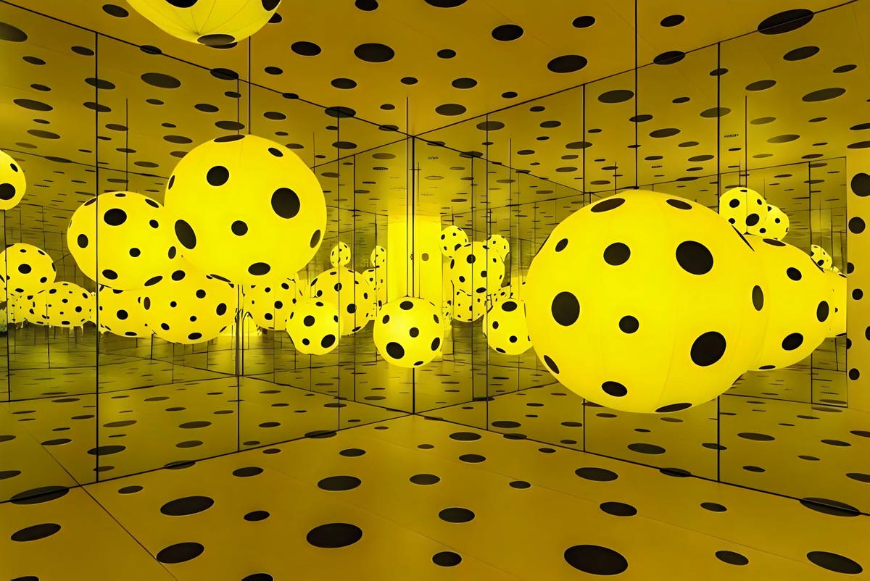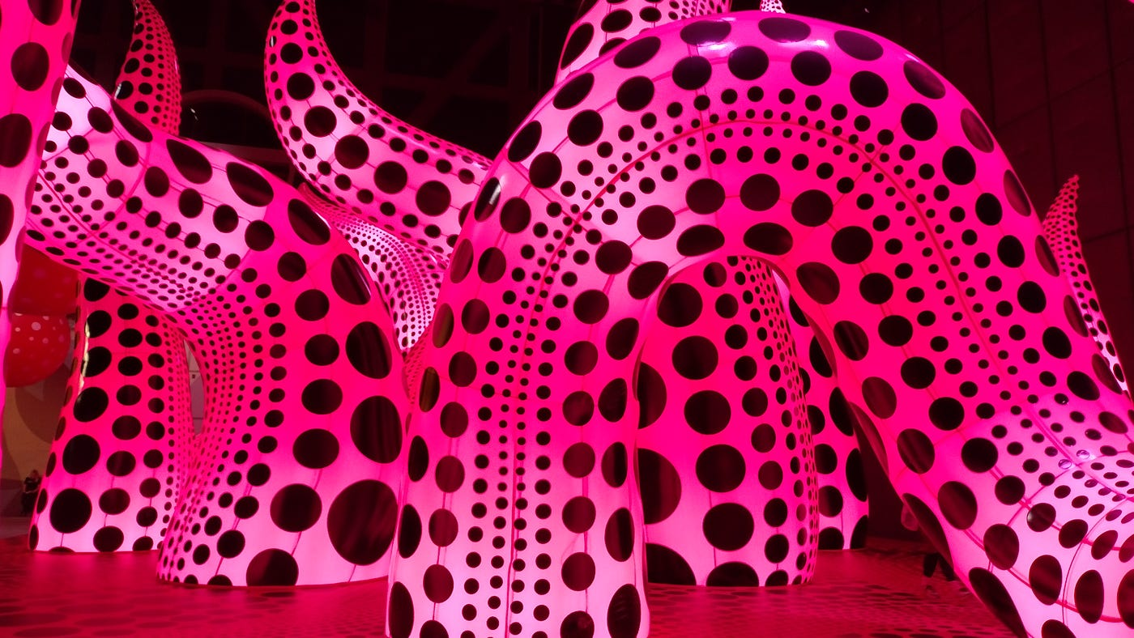

**Chatter topic 2:** What other artists do you know?

**Chatter topic 3:** Do you know anything about Japan? Would you like to go there one day?

**Chatter topic 4:** Which of these is your favourite and why?

