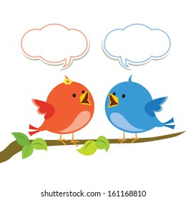**Millward Class Chatter topics**

**Spring 3**

1. Who do your family think Banksy is?
2. Is graffiti art?
3. What is the best painting you have ever seen? Why?
4. What type of music do you like, what is it that you like about it?
5. If you could go and see a band or artist perform live, who would you want to see?
6. Tell your family about what is happening in our book-Scribbleboy.

