Interesting facts
F1 cars are aerodynamic. This means that they have been carefully designed to reduce air resistance. An F1 car can reach speeds of over 200 miles per hour!
The Moon's gravitational pull is strong enough to move the oceans, creating tides. This means that the fuller the moon is, the higher the tides will be!

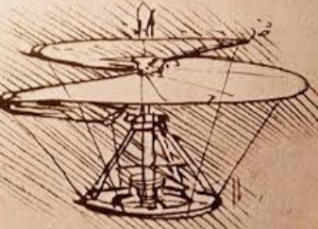
Leonardo Da Vinci was a famous artist. He was also a scientist and inventor, designing some incredible machines that used pulleys, gears, and levers, such as the helicopter and bicycle.
Word | Definition
force | An action that changes or maintains the motion of a body or object. Simply stated, a force is a push or a pull. Forces can change an object's speed, its direction, and even its shape.
magnetism | An invisible force or field that causes objects to attract or repel one another.
pole | Either of the two points of a magnet where the lines of magnetic force meet and are strongest.
predict | Think about what might happen in the future.
resistance | A force that opposes or slows down another force.
drag | A force that acts on an object in the opposite direction than that object is moving.
mechanical | Made of or has to do with machines or motors.
motion | the activity or process of continually changing position or moving from one place to another
Useful Pictures/Diagrams
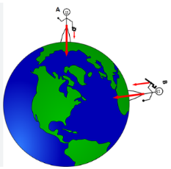
Earth’s shifting magnetic poles
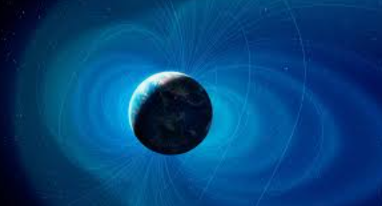

Gravity

Question: Is The Force With You?
- Can we identify how magnets attract or repel each other and attract some materials and not others?
- Can we predict whether two magnets will attract or repel each other, depending on which poles are facing?
- How does gravity work?
- How do forces such as drag and motion work?
- Do we understand that force and motion can be transferred through mechanical devices such as gears, pulleys, levers and springs?


