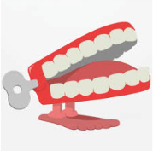**Dickens Class Chatter Topics**

**Autumn 2**

**How does my body work?**

**Chatter topic 1:** Do you like this abstract piece of art? Why/why not? What fruits can you see?

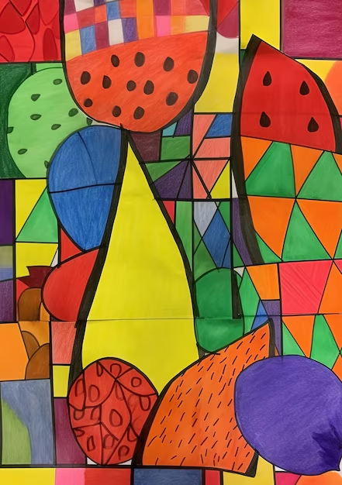

**Chatter topic 2:** What do humans need to stay healthy?

**Chatter topic 3:** What smells do I like? What smells do I dislike?

**Chatter topic 4:** What are the five senses? Which parts of the body do we use for each sense?