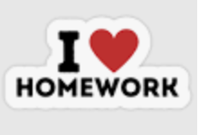
How does my body work?

 | Homework Options
Task 1 | Draw a picture of a member of your family and label the parts of the body.
Task 2 | Help your grown up to make your favourite meal at home. Can you write a list of the ingredients needed to make it?
Task 3 | Listen to the story ‘Oliver’s Vegetables’ https://www.youtube.com/watch?v=WZszls4lb5I  Now answer these questions about the story:  1. How did Oliver and Mum get to Grandpa’s house?  2. What did Oliver think was the best thing about Grandpa’s house?  3. Oliver said that he only liked one type of food, what was it?  4. Grandpa told Oliver that if he wanted to have chips he’d have to find something first. What did Oliver need to find?  5. What did Oliver find on Monday?  6. What vegetable had ‘crinkly leaves’?
Task 4 | Go on a senses walk with a grown up. Write a list of the different things you see/hear/smell/feel.
Task 5 | Keep a food diary for 3 days. Can you write down everything you eat?

