

Who was Isambard Kingdom Brunel and why was he important?
 | Homework Options
Task 1 | Use the internet the find some information about Brunel.
Task 2 | Draw a picture of Brunel.  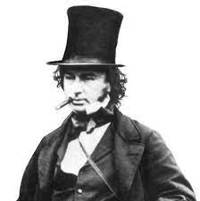
Task 3 | Build a bridge using lego, junk recycling, blocks or anything else you have at home.
Task 4 | Design a new logo for the Great Western Railway line.  
Task 5 | Look at this picture of a Victorian kitchen. How is it different to your kitchen at home.  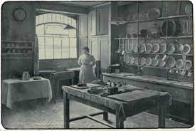
Task 6 | Find out what schools were like in the Victorian times.

