|  |
| --- |
| Question: What was it like in Ancient Greece? |
| 1. What important events happened in Ancient Greece and when did they take place? |
| 1. How did the Ancient Greeks live? |
| 1. What did the Ancient Greeks believe in? |
| 1. How did Greek culture influence the design of their everyday items? |
| 1. Can I design and make, taking inspiration from design throughout history? |

|  |
| --- |
| **Useful Pictures/Diagrams** |
|  |

|  |
| --- |
| **Interesting facts** |
| Marathons come from Ancient Greece. In Ancient Greece it is believed that a man called Pheidippides ran 26 miles from Marathon to Athens. He wanted to announce the news of the victory of the battle of Marathon. This is where the race comes from and why it is so long! |
| The yo-yo was invented in Ancient Greece. |
| They also invented the first alarm clock!  An engineer called Ctesibus created a system where pebbles would be dropped onto a gong.  This would then make a loud sound. |

|  |  |
| --- | --- |
| **Word** | **Definition** |
| ancient | Belonging to the very distant past generally thousands of years ago. |
| city state | Greece was split into separate groups called city states. They made their own rules, had their own laws and often clashed with each other |
| civilisation | The society, culture, and way of life of a particular area |
| democracy | The idea that every free person gets a vote and their opinion will be heard. |
| philosophy | The Ancient Greek world saw the birth of philosophy which is the art of thinking about life and the world we are in |
| demi-gods | The Ancient Greeks believed that their Gods came to Earth in human form and had relationships with mortal humans. Their children were known as demigods meaning half god and half mortal often with super human strength |
| acropolis | An ancient place located high above a city |
| immortal | Immortality or eternal life is the idea of something which is alive that will stay alive forever. The opposite of immortality is mortality, which means a living thing can die |

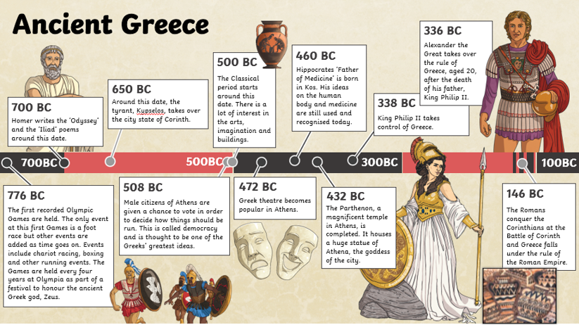

**Knowledge Organisers for: History Term: Autumn 1 Year group: 4/5**