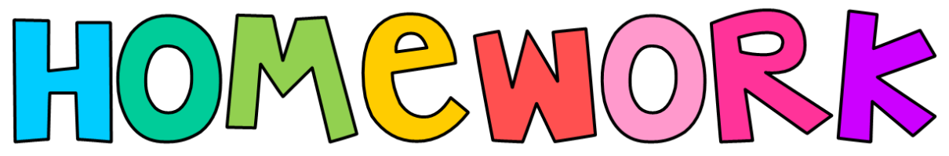

**Here are some extra tasks for you to choose from this term:**

**What can you find out about the Greek Alphabet? Its letters are very different to ours. Can you write some sentences in Greek?**

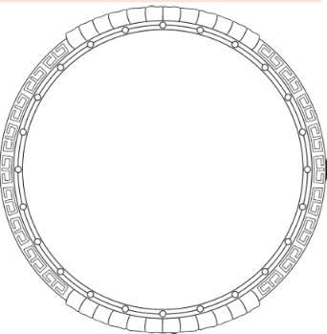**The Greeks created the Olympics Can you create a new game for the Paris Olympics? What would you call it? What equipment would you need and what would the rules be?**

**Greek soldiers carried a large, round shield called an aspis. It was made of wood and was curved, a bit like a large dish. Can you design your own one? What symbols would you have?**

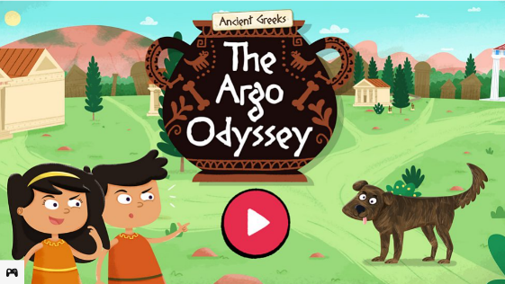**Why not play this BBC Bitesize Game.**

**Argo is missing! Can you find him? Join Cassandra and Helenus on an exciting adventure to find their beloved dog Argo.The quest will take you through the sights and sounds of Ancient Greece.** [**https://www.bbc.co.uk/bitesize/topics/z7nrydm/articles/z2ngf82**](https://www.bbc.co.uk/bitesize/topics/z7nrydm/articles/z2ngf82)

**Can you recreate this Greek frieze? You could use any media you like (pencils, chalk, pastels, paints…)**

