Where do I live?

 | Homework Options
Task 1 | Can you draw a picture in the style of a mosaic using squares? You could draw squares onto your page and colour in the picture or cut up pieces of coloured paper into squares and stick them onto the page to create a picture.  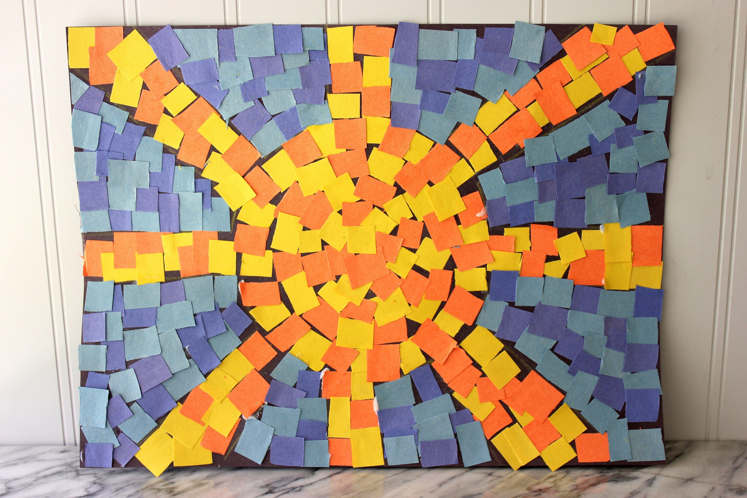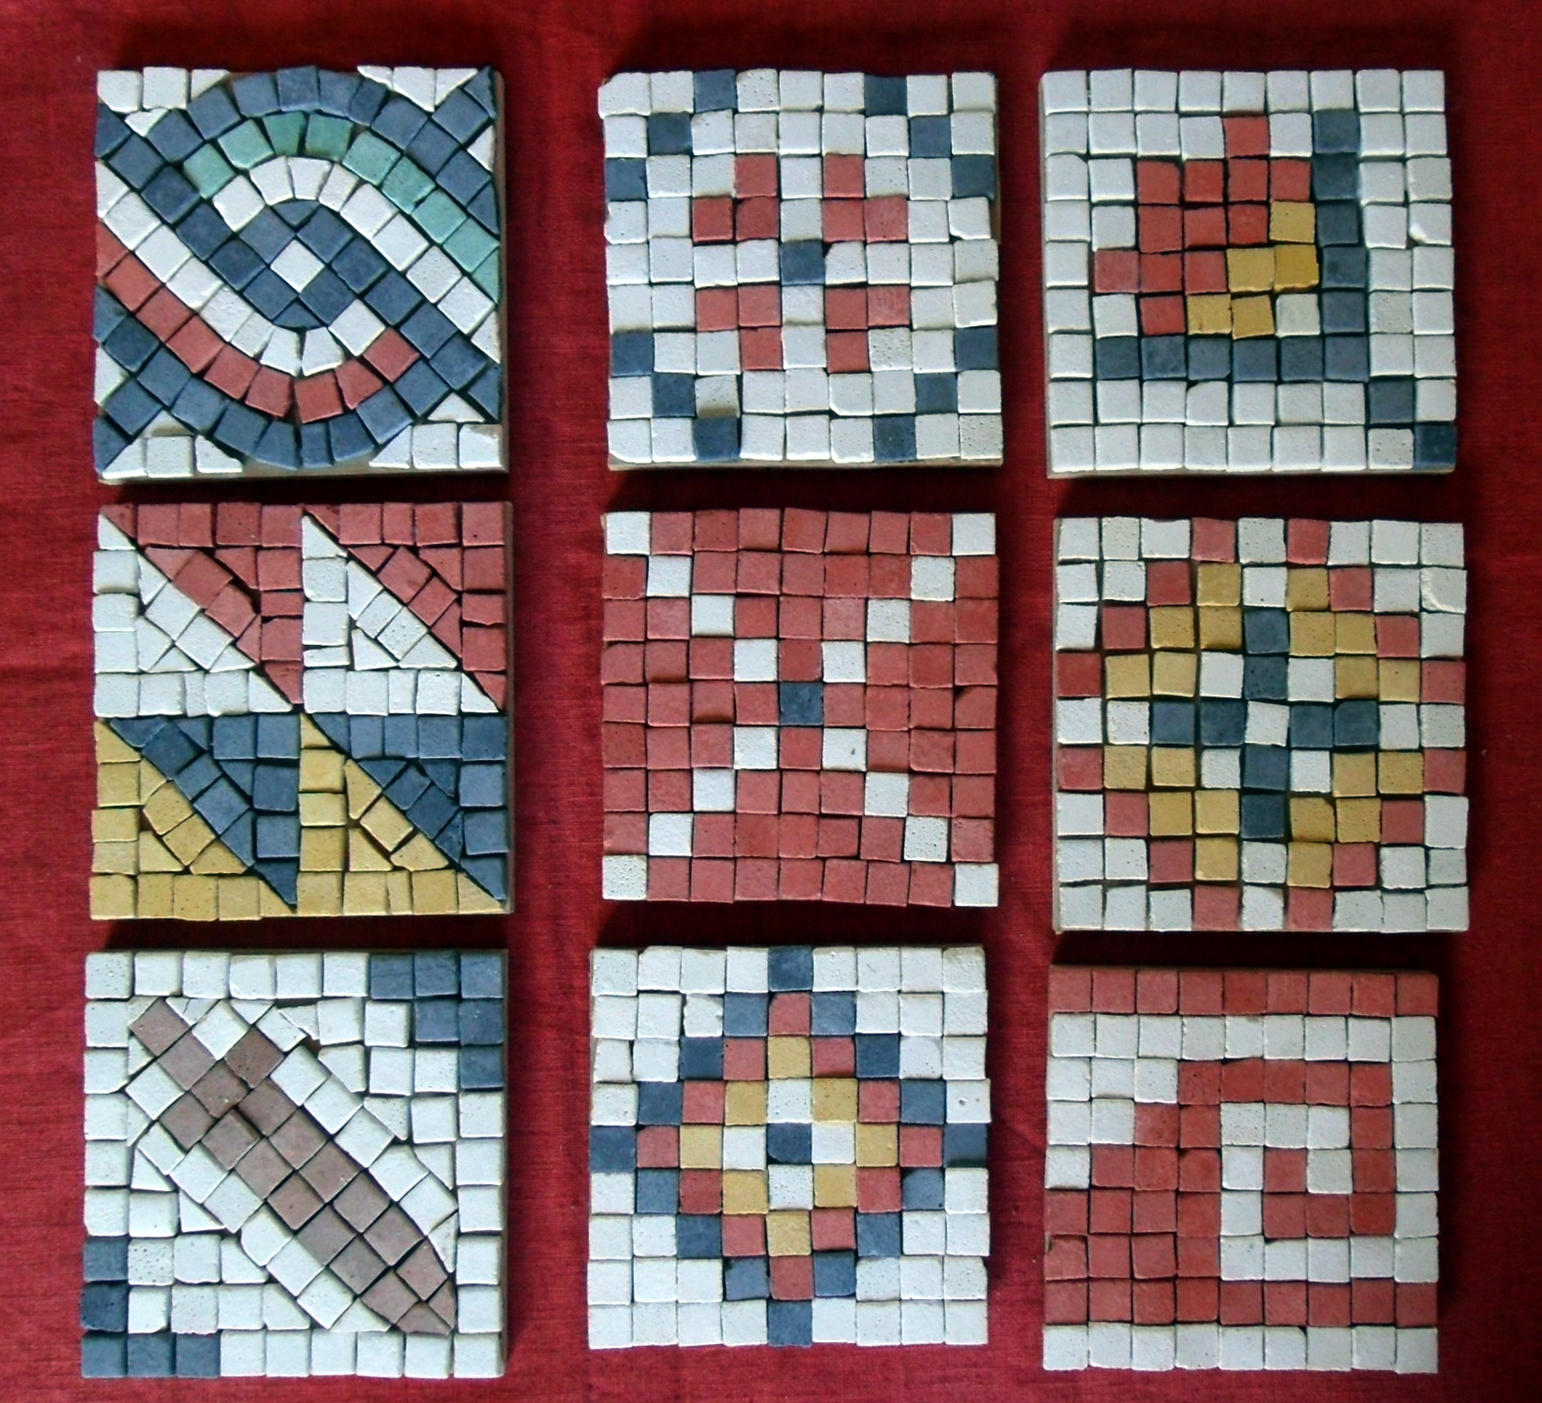
Task 2 | Do some research on the Roman Baths in Bath and create a fact file all about them.  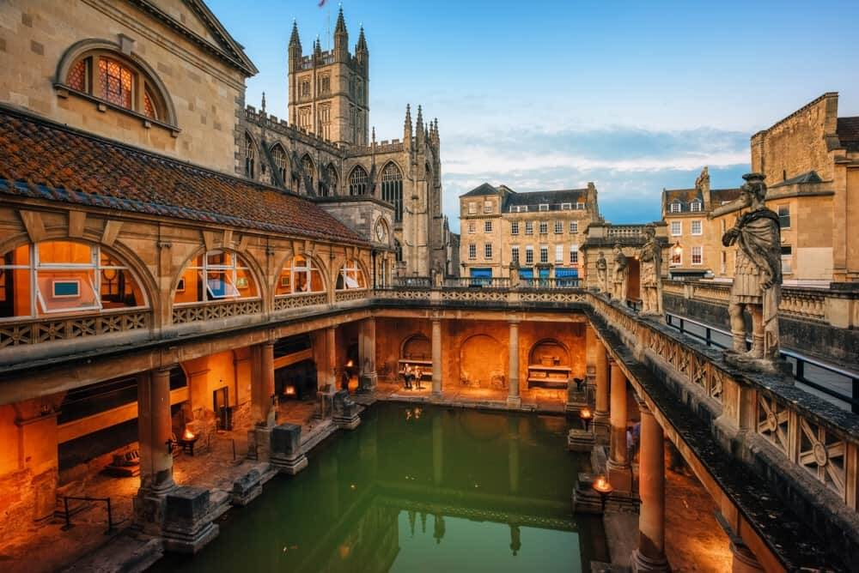
Task 3 | Create a poster that the Romans could have used to encourage people to come to the Roman Baths in Bath. Remember, it was a place that people could swim but also somewhere where they could do other exercise, have a massage, go in the steam room and socialise with their friends.
Task 4 | Pretend you are a Roman soldier who has just arrived in Roman Britain from Italy. Write a letter home to tell you family all about Bath.
Task 5 | Practise your times tables using TT Rockstars at home. Ask us if you need your log on details.

