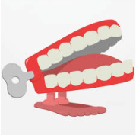
Summer 6
What did the Romans leave behind in Bath?
Chatter Topics for Mason Class

Chatter topic 1: Imagine you are a Roman soldier who has just arrived in Bath all the way from Italy. It is the first time you have been away from home. How will you be feeling?
Chatter topic 2: Do you think that the Romans were right to come and invade our country? They created a lot of good things that we still have today and some people say our country is better for the influence they had. Others say that they should have stayed away. What do you think?
Chatter topic 3: Look at this picture showing life in Roman Britain. How can you tell it depicts life more than 1,500 years ago? What is the same and what is different?

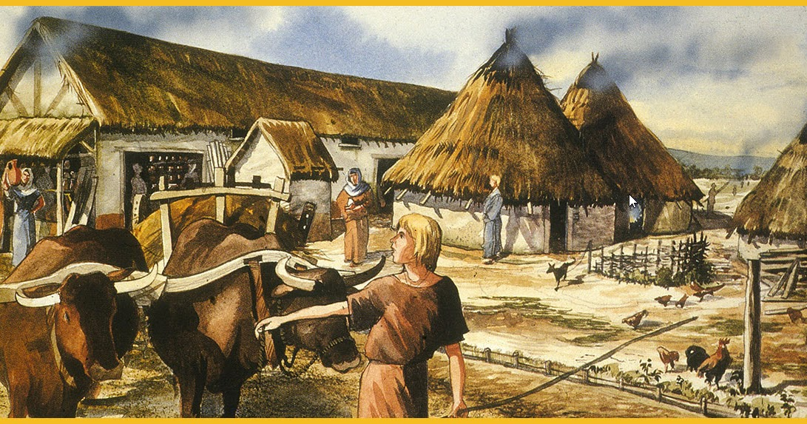

Chatter topic 4: Imagine you could go back in time to the Roman era and visit the Roman Baths. What would you enjoy most about going there – the pool, the steam room, the massages, socialising with your friends? Or maybe all of them? What would you do first?

