What happened in London, in 1666?

 | Homework Options
Task 1 | Can you draw a portrait of King Charles II? Who was the King during 1666?
Task 2 | To escape the fire, many people used boats and horse and cart. Can you make a model of a boat, using junk modelling?
Task 3 | Can you write a diary entry of your day?
Task 4 | This is a photograph of St Paul’s Cathedral, which was destroyed in the fire, and re-built. Can you sketch it?  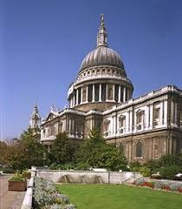
Task 5 | Can you sing ‘London’s Burning’? Can you make your own verse up to add in? Do you know any other songs about London?

