Here are some extra tasks for you to choose from this term:
To help you remember your writing skills from last term, can you write a short play but set it in the Ancient Kingdom of Benin?
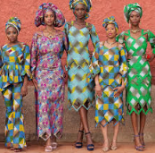
If you were a powerful Benin Oba, what rules would you put in place for your people?
Traditional Benin fabrics were very colourful, can you design your own set of clothes using similar patterns?

The Benin loved to make jewellery from coral beads. Can you make some using junk modelling?
Can you go on Google maps and find out how far it is to the capital of Nigeria, Abuja, from your house?

