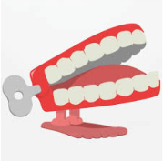
Summer 6
What happened in London, in 1666?
Chatter Topics for Dickens Class

Chatter topic 1: Have you ever been to London or seen it on television? What would you like to visit there?
Chatter topic 2: Look at the picture of houses in 1666. How are they different to houses today?
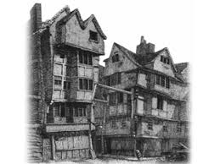
Chatter topic 3: What words can you think of to describe a fire? Can you mind map adjectives and expanded noun phrases?

Chatter topic 4: If you had been there during the fire, what three items would you have saved?

