Summer 6 Chatter Topics for
Fox Class

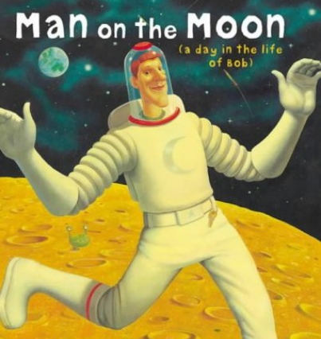

- If you were an explorer, where would you go?
- What do you think you can see on the moon?
- How would you like to travel to the moon?
- What sort of moon landing party would you throw?
- What causes the moon to shine?
- What else happened before you were born?

