What do animals, including humans, need to survive?

 | Homework Options
Task 1 | Draw a big suitcase and draw and label things you would need to survive for a week outside in a forest.
Task 2 | Draw, paint or create a collage of your favourite animal in the habitat they live in.  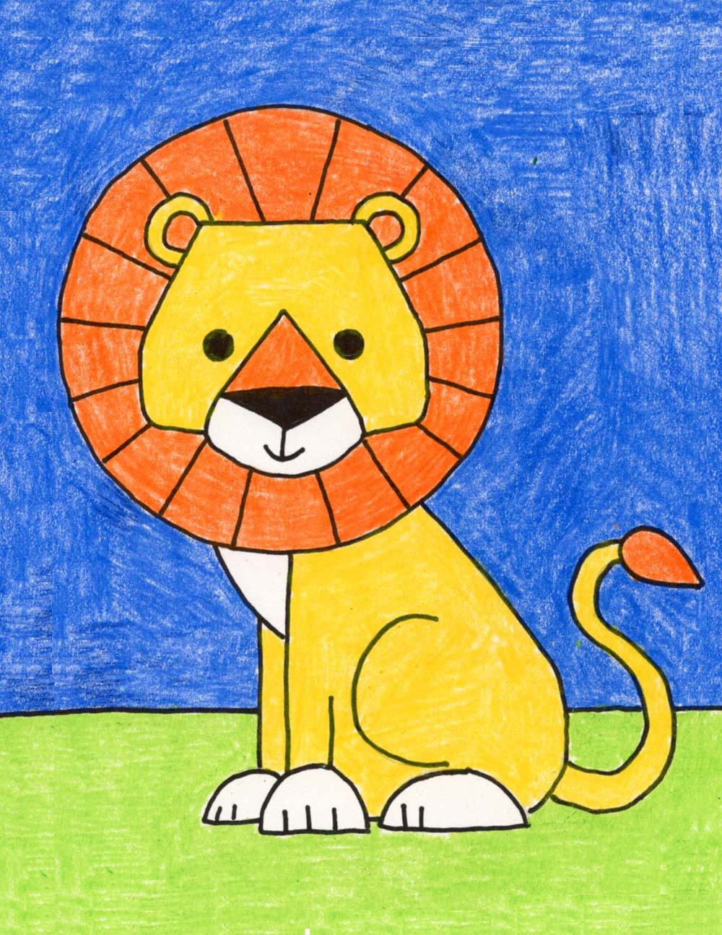
Task 3 | Can you write a story about an animal who wakes up and is lost far away from home and needs to get back to their natural habitat. Maybe it could be a polar bear who is lost in a desert, or a lion who is lost far out at sea, or a whale who is stranded on a beach and needs to get back into the ocean. How will they get home?
Task 4 | Do some research on an animal that you don’t know much about. Find out what they look like, what they eat, where they live, how big their babies are when they are born and how long they live. Present the information in a poster. Some interesting animals that you might like to find out about could be – lizards, whales, crocodiles, eagles, foxes or maybe you can think of something else?
Task 5 | We should eat a healthy died in order to survive. Draw a healthy plate of food and label it or create a healthy menu with a main meal, pudding and drink.

