Home learning in Fox

In order to help your child learn, we encourage you to read with your child daily. This is to practise reading skills, comprehension and reading for pleasure. We would like you to spend time supporting your child to learn to read and spell the statutory words for Year 1. You could concentrate on 5 of these at a time. These are available on our website. Please ask your child about the maths that they are completing in class and practise number bonds to 10.
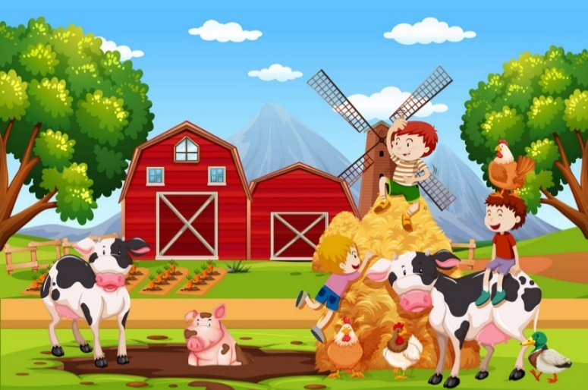

In addition to this we have some optional home learning linked to our big question this term, which is ‘what am I?’ If you would like to help your child with our topic this term below are some ideas.

- Draw and label all your favourite animals
- Research facts about your favourite animal
- Construct a new house for an animal
- Create a picture of all the things that you need to help you grow
- Go on a sensory walk and draw all the things you find on your way
- Draw and label a picture of something you could do as a baby and something you can do now.

