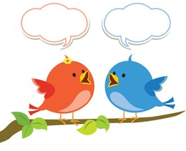
Millward Class Chatter Topics

- Find out what your family know about how electricity is used in your house? As you learn more, share your knowledge with them.
- Have a family debate-What is the most important scientific discovery in history so far? - make sure you explain why and listen to each other!
- Tell your family what you have learnt about electricity in our topic so far.
- Do you know someone whose job involves electricity? Could you interview them?
- Take a trip to the local library. Can you find any books about electricity?

