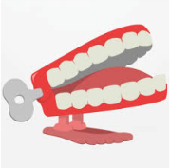
Summer 5
What do animals, including humans, need to survive?
Chatter Topics for Dickens Class

Chatter topic 1: If you were stuck on a desert island, which 5 things would you choose to have with you in order to survive?
Chatter topic 2: How are fish adapted to live in the sea, how have camels adapted to live in deserts and how have polar bear adapted to live in snowy climates?
Chatter topic 3: What things do you need to help you stay happy and to help with your emotional survival?

Chatter topic 4: What would happen if there were no plants? Would we be able to survive?

