Summer 5 Chatter Topics for
Fox Class

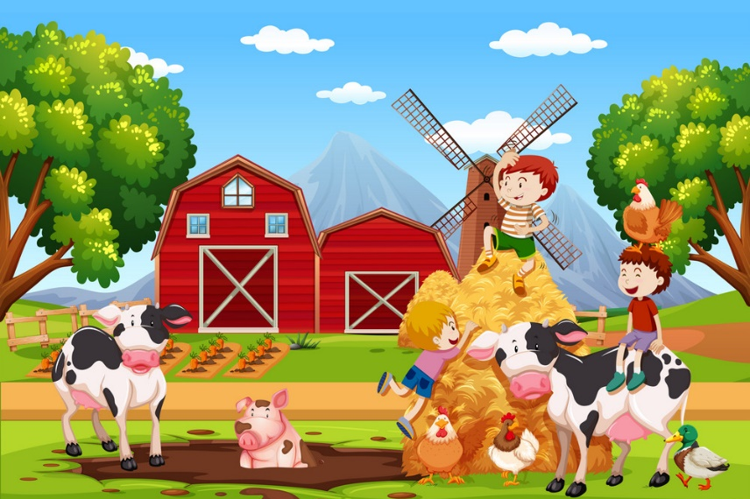

- How have you changed since you were a baby?
- How many animals can you name?
- What do you think you need to help you grow?
- Do you think animals need the same things or different things to help them live and grow?
- Where might you find different animals?
- What different parts of your body help you in different ways?

