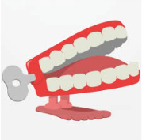
Spring 4
What were the arts like in the 1940s?
Chatter Topics for Dickens Class

Chatter topic 1: If you could live anywhere in the United Kingdom, where would you live – the mountains, the coast, in a town or in a village? Why would you choose to live there?
Chatter topic 2: If you could design and build something in Corsham what would it be? Maybe a new playground, an ice rink, an outdoor pool, a cinema or something else?
Chatter topic 3: Look at this photo of Corsham Court taken over 100 years ago? What is different from houses today?

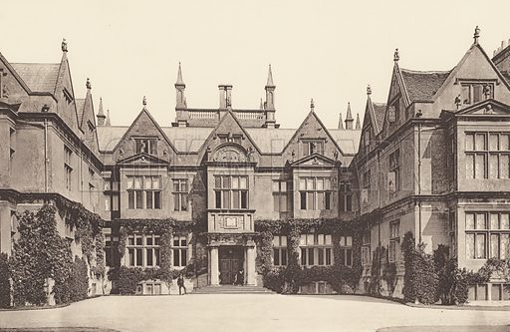

Chatter topic 4: What is your favourite place in Corsham and why?

