Spring 4 Chatter Topics for
Fox Class

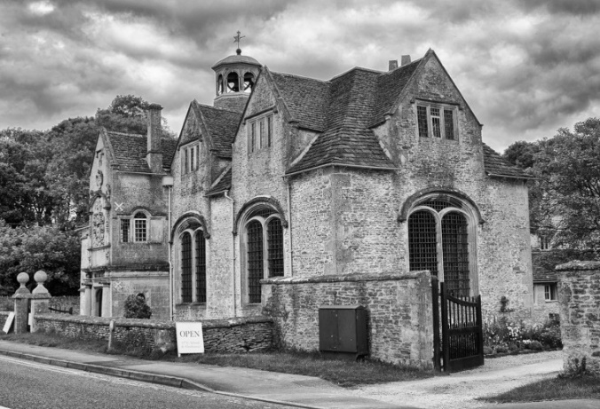

- What are your favourite places in Corsham and why?
- How could you describe your favourite places in Corsham?
- What was Corsham like in the past?
- What was school like in the past? (ask a grandparent or relative)
- What questions could you ask someone to find out about the past?
- What questions can you ask to find out about Corsham?

