Spring 3 Year 4/5
What were the Arts like in the 1970s?
1 | How could you use a range of stitches to create different textures, patterns and shapes with materials?
2 | How could you use technical vocabulary to describe music from the 70s?
3 | How could you create a song where the sound and lyrics have an effect on the listener?
4 | How could I compose, perform and evaluate music from the 70s using my knowledge of musical notation and vocabulary?
5 | Can I use the work of an artist from the 70s to inspire my own original piece?
Interesting Facts
In 1974 Swedish Band Abba win the Eurovision song Contest with their hit Waterloo.
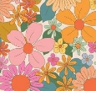
70s fabric designs were bright, bold and often inspired by nature.
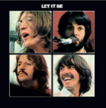
The Beatles broke up on April 10, before the release of their last album, Let It Be.
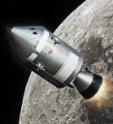
Apollo 13 returned safely to Earth despite many challenges. It was the mission which gave us the quote “Houston, we have a problem!”
Word | Definition
inspire | to give someone the desire, confidence, or enthusiasm to do something we
texture | how something feels when it is touched.
genre | the type or style of a film, book, play
funk | a style of dance music based on jazz and blues, with a strong, repeated bass part.
culture | beliefs and behaviors that are traditionally practiced by a group of people
trend | what's hip or popular at a certain point in time.
expression | the action of making known your thoughts or feelings known
tie dye | produce patterns by tying parts of it to shield it from the dye
