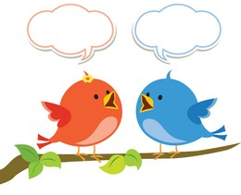
Millward Class Chatter Topics

- Do you have any relatives that were alive in the 70s-ask them to tell you what they remember?
- Learn the words to an Abba song and teach them to a friend or someone in your family.
- Can you find out what children watched on tv in the 70s and tell someone about one of the programmes, who were the characters, what was the setting and what happened?
- What can you find out and share about the space missions of the 70s?
- Tell someone in your family about a book written in the 1970s by Roald Dahl and persuade them why they should read it, even if they are an adult!

