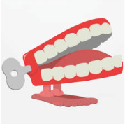
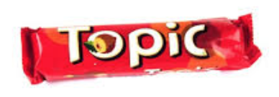
Spring 3
What were the arts like in the 1940s?
Chatter Topics for Dickens Class

Chatter topic 1: Recycling started in the 1940s when World War II was on and people had to “make do and mend” because people couldn’t get hold of lots of thing. For example, people used curtains to make clothes! What do we recycle today?

Chatter topic 2: List to some music from the 1950s. You might enjoy listening to Louis Armstrong. What do you think of it? What instruments can you hear? How is it different to the music we listen to today? Here’s a link of some of his music.
Louis Armstrong - Hello Dolly Live (youtube.com)

Chatter topic 3: Look at this piece of art created in the 1940s. What does it show? Do you like it and why? What shapes can you see in it?
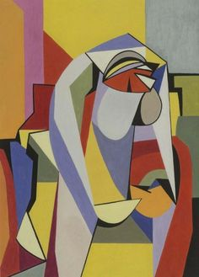
Chatter topic 4: What is your favourite song or piece of music? How does it make you feel and why do you like it so much?

