Spring 3
Chatter Topics for
Turner Class

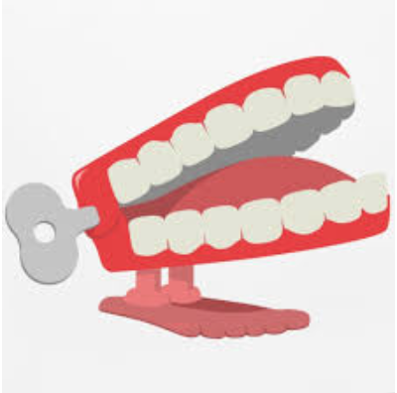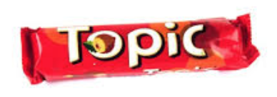
Chatter topic 1:
What songs do you know from the 1960?
Chatter topic 2:
What famous artists were around in the 1960’s
Chatter topic 3:
What is Pop Art?
Chatter topic 4:
What is a biography- have you read any?
Chatter topic 5:
What song lyrics do you know really well and do you know the story behind them?

