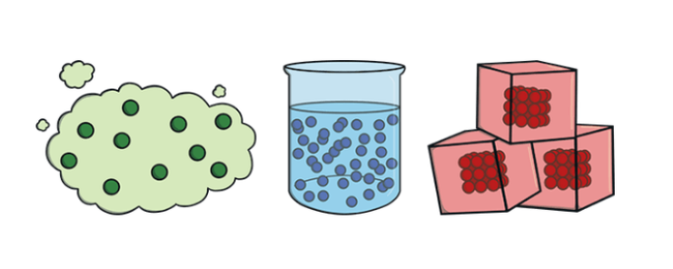
Knowledge Organiser for: Science Term: 2 Year group: 4/5
 | Big Question: What state am I?
1 | How could you group everyday materials, based on their: hardness, solubility, conductivity and response to magnets?
2 | Which materials dissolve in liquid and how do you get them back?
3 | How might mixtures be separated, using filtering, sieving and evaporating?
4 | What are metals, wood and plastic used for and why?
5 | What is a reversible change?
6 | What is an irreversible change?
7 | How do you plan an investigation?
8 | What measurements could you take in your investigation?
9 | How could you record the results and report/present them?
10 | How could you use your results to make predictions?
Interesting Facts
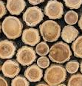
Wood was the first drawing material.

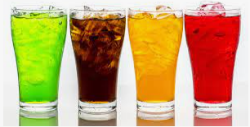
Carbonated beverages are made by dissolving carbon dioxide gas into liquid at high pressure.
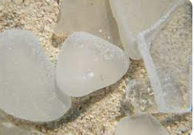
Glass is made from very fine sand. It is heated until it melts.
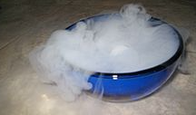
Dry ice exposed to normal air gives off carbon dioxide gas that is odourless and colourless. The gas is so cold that when it mixes with air it cools in the air to fog. It is often used in theatres to make fake fog or smoke.
Word | Definition
Solids | One of the three states of matter. Solid particles are very close together, meaning solids, such as wood and glass, hold their shape.
Liquids | This state of matter can flow and take the shape of the container because the particles are more loosely packed than solids and can move around each other. Examples of liquids include water and milk
Gases | One of the three states of matter. Gas particles are further apart than solid or liquid particles and they are free to move around. A gas fills its container, taking both the shape and the volume of the container. Examples of gases are oxygen and helium.
Evaporation | When a liquid turns into a gas or vapour.
Condense | When a gas, such as water vapour, cools and turns into a liquid.
Sieve | strain solids from liquids
Dissolve | to become incorporated into a liquid so as to form a solution.
Conduct | transmit a form of energy such as heat or electricity

